Information request for challenge 1: MPT scheduling
UPC teams have collaborated and compiled a list of questions regarding scheduling optimization. The questions are as follows:

Mixing Questions:
- Which are the exact sizes of the mixers?
M-2,5 2,5 m3
M-3,5 3,5 m3
M-5 5 m3
M-6 6,5 m3
M-7 6,5 m3
M-8 8 m3
M-12 12 m3
M-16 16 m3
M-25 25 m3
- How long does it take to fill the mixers?
It depends on the products. Information in the attached file.
- How long does it take for each mixer to complete the mixing process and how long does each different product take to mix?
- It depends on the products. Information in the attached file.
- Which mixers do what? (Specifications of possible mixes that only can be manufactured in a particular mixer)
Hard acids can only be produced on mixers 6 & 7.
- Which products can be stored in a mixer and for how long?
All products can be stored more than a shift in the mixer except the productions of hard acids.
- How long does it take to test the product inside the mixer?
Quality control time is approximately 15 min.
- What raw materials do we need to introduce manually? (If this is relevant)
Info not relevant.

Filling lines Questions:
- Which production line has the capacity to produce which output?
L-2 Jerrycans of 60L, drums of 200L and IBCs of 1.000L.
L-3 Jerrycans of 20L & 30L.
L-5 Jerrycans of 60kg, drums of 200kg and IBCs of 1.000kg (same as L-2). Besides, it can fil jerrycans of 20L, 25L & 30L from M-6 & M-7 when are productions of hard acids.
L-7 Jerrycans of 5L, 10L, 20L & 25L.
- Which mixer is connected (or not connected) with which filling line?
All mixers are connected with all the filling lines except M-7 which are directly connected with L-5 (contains hard acids). Attached imaged of the manifold.
- How long does it take to fill the different products into the different packaging sizes? (Lines cycle times or lines hourly capacity for each format)
It depends on the amount of each production. The smaller the longer it takes. Information in the attached file.

- How long does a changeover take at a filling line (removing, storing, retrieving new packages, preparing new filling)?
L-2 10’
L-3 60’
L-5 Same as L-2. If we have to fil hard acids 20’.
L-7 Formats of 5L & 10L take 6h. For the remaining sizes 30’.
- What other constraints are in place for the mixers and filling lines?
(We do not consider any other constrain for the scope of the project).

Product Questions:
- What are the different sizes of the packages (IBCs and jerrycans)?
Jerrycans: 5L, 10L, 20L, 25L, 30L & 60L.
Drums: 200L.
IBCs: 1.000L.

- In what batch sizes can the products be produced if there is a minimum quantity?
It means that we don’t understand the question.

- Is there any product that has priority over others?
No, priorities are defined by the production plan made by supply team.

- Are there any products we should avoid putting one after the other?
After produce 911776 in M-12 we can only produce the following products: 1471816, 1728924, 1306519, 2259890 & 656647.

- Could you supply us with a sample of data files showing the demand (production orders) for several weeks? (We talked about a sample of 12 weeks in our visit).
Attached.

- After being filled, where are the final products stored? (If we need to take that into account)
No need to consider.

Cleaning Questions:
- How much time does it take to clean a mixer?
15’.
- How many mixers can be cleaned at the same time?
Just 1.
- How much time does it take to clean a filling line?
20’.
- How many filling lines can be cleaned at the same time?
Just 1.
- Is there any special cleaning? If yes, for what products and how long does it take?
- Can we clean a mixer and a filling line at the same time?
No.

General questions:
- What are the exact working times? (Working hours, number of shifts, breaks, working days/week…)
Working hours: Monday to Friday, from 6AM to 10PM.
Number of shifts: Morning shift (6AM to 2PM) & afternoon shift (2PM to 10PM).
Breaks: 30’ for each shift.
- How is the scheduling process currently being managed? Which tool or methodology are being used?
APO & SAP (PFS).
- Could we see what a current production plan looks like and which considerations are taken into account when planning?
Attached an example of working plan at the end of the document. We take into account the availability of raw materials and packaging, needs of customers, maintenance tasks on mixers/filling lines…
- Are there any further assumptions we can make (e.g., quality is always perfect as you said during the visit)?
Consider the times of the excel document attached.
- What is the breakdown rate (e.g., MTBF) and how much delay does a breakdown cause (e.g., MDT), in both mixer and filling lines?
This information must not be considered for the production plan.
- Is there maintenance of the mixers or filling lines? If yes, how often? How much time does it take? (If it should be considered for the scheduling method)
Yes, there are maintenance tasks for mixers and filling lines but, is the maintenance department who tell us the dates when they will intervene. The time which they need to realize the tasks depends on each mixer/filling line and the kind of maintenance.
- Could we receive a drawing or a layout of the production area?
Not needed.

We appreciate your prompt response, as we are eager to begin the scheduling optimization process.

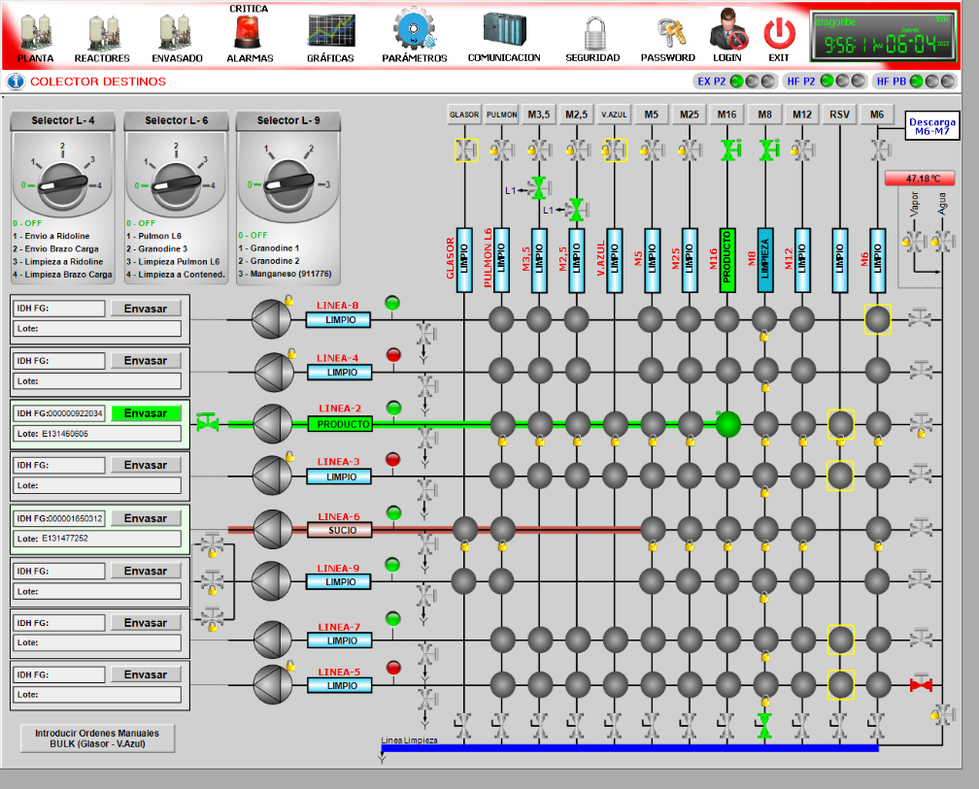
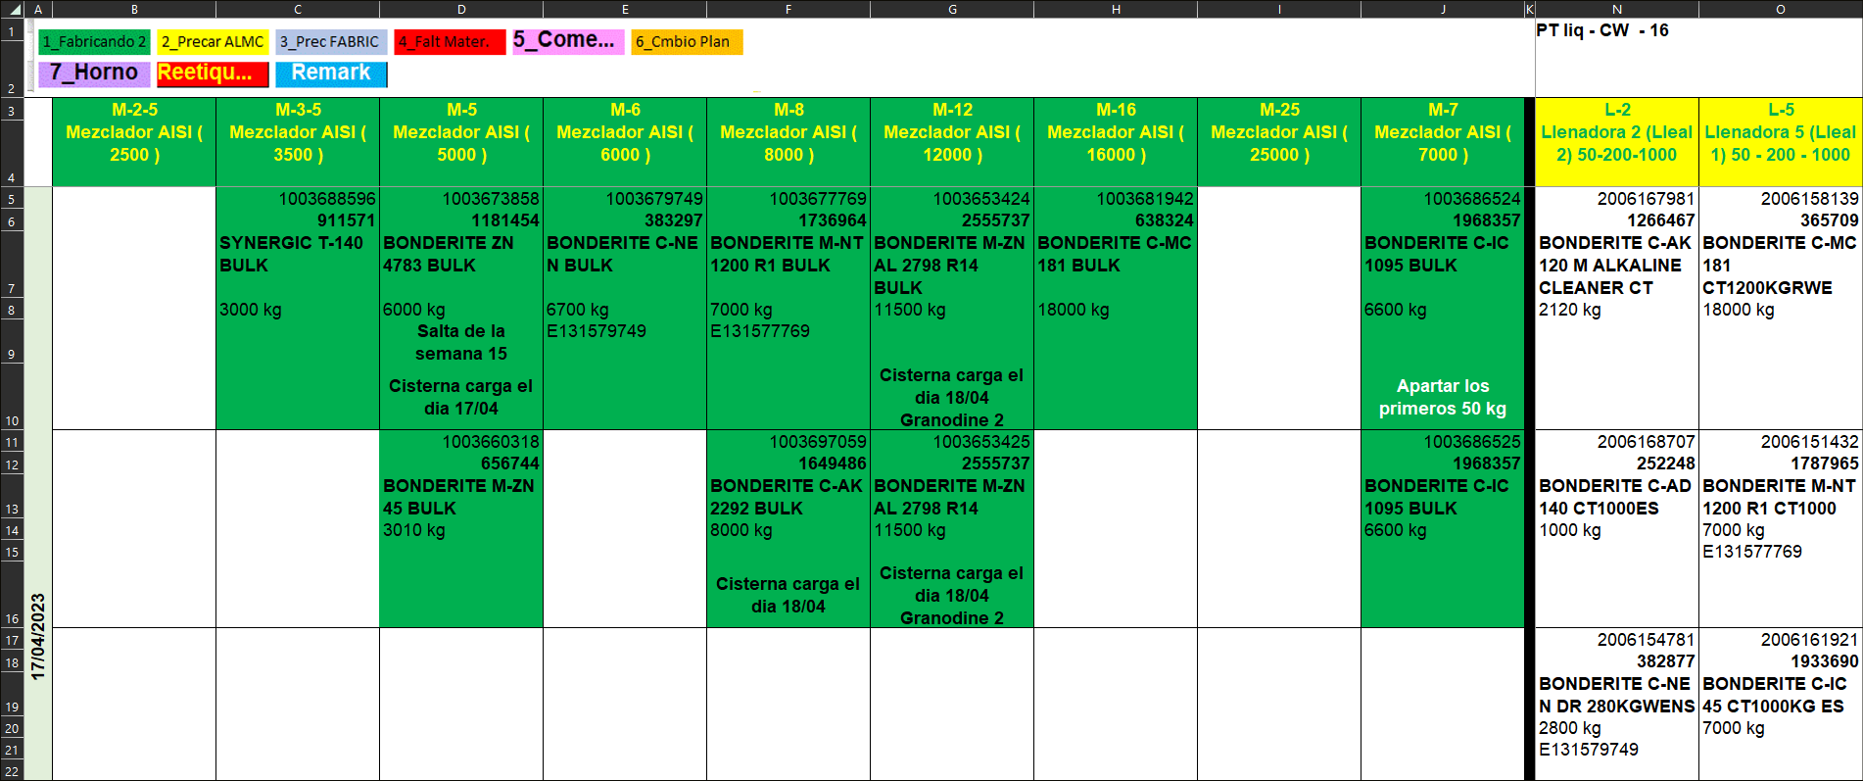
Example of a part of our actual production plan:

