Quick Reference Card | The purpose of this Simio quick reference card is to summarize the key points that a student or a routine user needs while building a new model.  Contributed By:  Ayedh Almutairi

- Model Windows:
- Standard Library:
- What is an Object?
- Results and Experiments:
The red circle in figure (1) below identifies the columns and their symbols. Columns may be moved around within the pivot grid. The up/down arrow may be used to sort the rows within a column into alphabetical order.
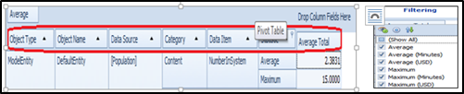Figure 1. Pivot Table Columns and Filtering
  - Dashboard reports:
Dashboard reports allow you to display a dashboard based report of generated model data. A dashboard allows you to organize and present model information that is customizable and easy to read. Model data can be displayed in many graphical forms such as grids, charts and gauges. It also allows you to customize your dashboard by adding images, text boxes and filter ranges.
  - Reports:
The Reports panel of the Results tab displays a traditionally formatted report that provides flexible visual formatting for inclusion in printed documents and is useful in presenting results to others. Reports are provided for both a single scenario and for comparing two scenarios.

  - SMORE Plots
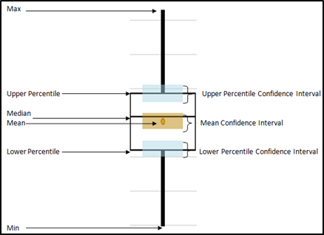Figure 2 SMORE plot Components
- Processes
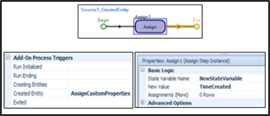Figure 3 Add On Processes Steps

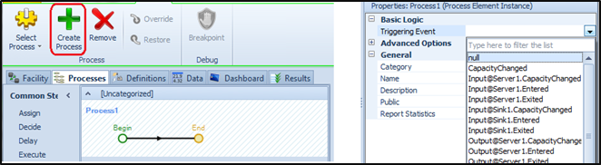
Figure 4 Event Triggered Processes Steps

- Working with Model Data

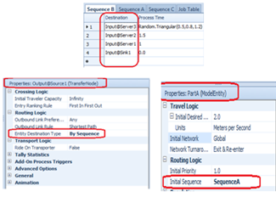Figure 5. Sequence Table Steps
- Tokens Vs Entities:
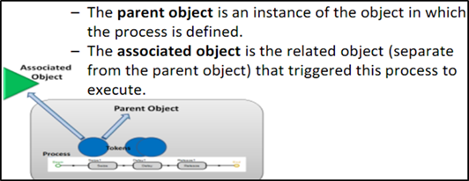Figure 6 Relationships between Tokens, Objects, and Processes
- Animations:
It used for these purposes:
8.1 visualization & communication
8.2 verification

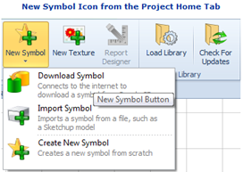Figure 7. New Symbol Icon

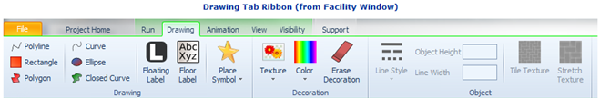Figure 8. Drawing Tab Ribbon
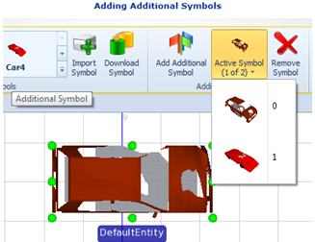
Figure 9. Additional Symbols

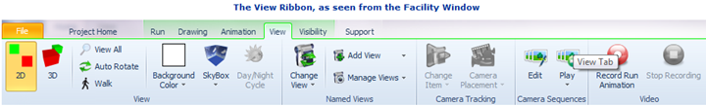
Figure 10. View Ribbon

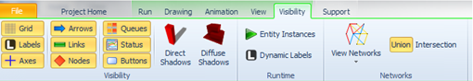
Figure 11. Visibility Ribbon

- Debugging Tools.

- Risk Based Planning and Scheduling:
You need to download the Simio Enterprise Edition to have the planning tab in your model.

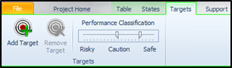
Figure 12. Target
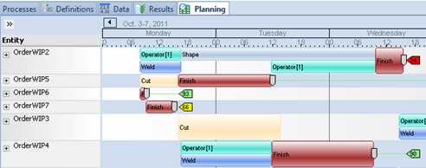
Figure 13. Entity WorkFlow

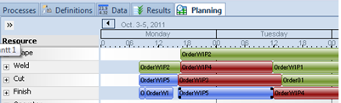
Figure 14. Resource Plan

- Bibliography
W.David Kelton, J. Smith, D Sturrock. (2014). Simio Simulation : Modeling, Analysis, Applications. Simio LLC.

Contributed By:
Ayedh Almutairi

